Student Name : Toh Yi Kang

Group : SCS1

Date : 28/03/2024

LAB 4: ANALZING NETWORK DATA LOG

You are provided with the data file, in .csv format, in the working directory. Write the program to extract the following informations.

Exercise 4A: TOp TALKERS and LISTENERS

One of the most commonly used function in analyzing data log is finding out the IP address of the hosts that send out large amount of packet and hosts that receive large number of packets, usually know as TOP TALKERS and LISTENERS. Based on the IP address we can obtained the organization who owns the IP address.

List the TOP 5 TALKERS

Rank | IP address | # of packets | Organisation
1 | 193.62.192.8 | 3041 | European Bioinformatics Institute
2 | 155.69.160.32 | 2975 | Nanyang Technological University
3 | 130.14.250.11 | 2604 | National Library of Medicine
4 | 14.139.196.58 | 2452 | Indian Institute of Technology
5 | 140.112.8.139 | 2056 | AS17716 National Taiwan University

TOP 5 LISTENERS

Rank | IP address | # of packets | Organisation
1 | 103.37.198.100 | 3841 | A*STAR
2 | 137.132.228.15 | 3715 | National University of Singapore
3 | 202.21.159.244 | 2446 | Rpnet
4 | 192.101.107.153 | 2368 | Battelle Memorial Institute, Pacific Northwest Division
5 | 103.21.126.2 | 2056 | Indian Institute of Technology Bombay

Exercise 4B: TRANSPORT PROTOCOL

Using the IP protocol type attribute, determine the percentage of TCP and UDP protocol

 | Header value | Transport layer protocol | # of packets | %
1 | 6 | TCP | 56064 | 80.818798
2 | 17 | UDP | 9462 | 13.639902

Exercise 4C: ApplicationS PROTOCOL

Using the Destination IP port number determine the most frequently used application protocol.
(For finding the service given the port number https://www.adminsub.net/tcp-udp-port-finder/ )

Rank | Destination IP port number | # of packets | Service
1 | 443 | 13423 | HTTPS
2 | 80 | 2647 | HTTP
3 | 52866 | 2068 | Dynamic/Private Ports
4 | 45512 | 1356 | Unassigned
5 | 56152 | 1341 | Dynamic/Private Ports

Exercise 4D: Traffic

The traffic intensity is an important parameter that a network engineer needs to monitor closely to determine if there is congestion. You would use the IP packet size to calculate the estimated total traffic over the monitored period of 15 seconds. (Assume the sampling rate is 1 in 2048)
Mainly summing up all packet size (in bytes already) together, which is the total size for one sample. Total traffic wil be the (sum*2048 samples)/(2^20) – 2^20 conversion to convert to MB.

Total Traffic( MB) | 126519.184 MB

Exercise 4E: ADDITIONAL ANALYSIS
Please append ONE page to provide additional analysis of the data and the insight it provides.
Please limit your results within one page (and any additional results that fall beyond one page limit will not be assessed).
Top 5 Communication Pairs based on number of packets between organizations:
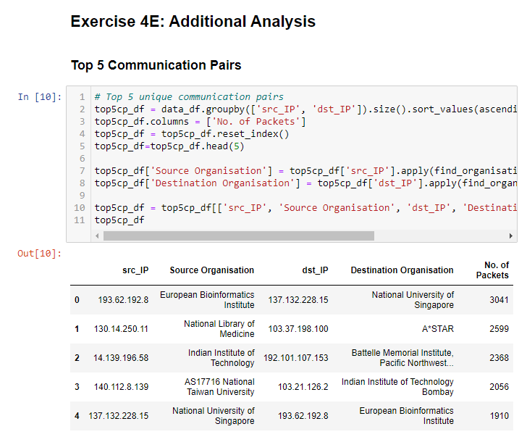

Visualization of top 5 communications pairs:

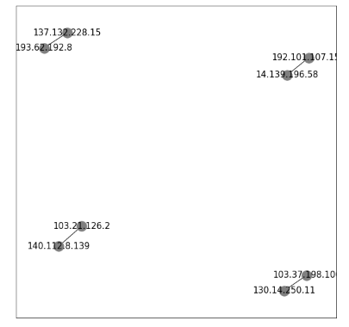
Although we state out the top 5 communication pairs, there are only 4 shown in the graph. This is mainly because the first and fifth communication paris have the same IP hosts but in different directions. Since the graph shown is non-directional, we can only display mainly first to fourth communication pairs since the fifth pair is technically same as the first pair.

Exercise 4F: SOFTWARE CODE
Please also submit your code to the NTULearn lab site.
